**Twitter Overspending A/B testing**

**Observations and insights for questions:**

**Tasks:**

1. **How many campaigns have overspent of greater than 1% of their budget in the control group? In the treatment group?**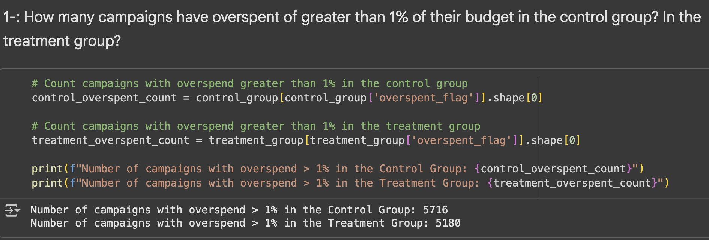

**Key Insights:**

The A/B test comparing click-based and impression-based billing models reveals a significant reduction in campaign overspending with the impression-based approach.

* **Overspent Campaigns:**
  + **Control Group (Click-Based):** 5,716 campaigns overspent by more than 1%.
  + **Treatment Group (Impression-Based):** 5,180 campaigns overspent by more than 1%.
* **Effectiveness of Impression-Based Model:**The treatment group experienced 536 fewer overspent campaigns, demonstrating the impression-based billing model's success in reducing budget overruns.
* **Positive Impact:**
  + **Advertiser Trust:** Lower overspending fosters greater confidence among advertisers, as their budgets are more accurately managed.
  + **Operational Efficiency:** Reduced overspending leads to improved billing precision and fewer budget disputes, enhancing Twitter's operational effectiveness.
  + **Business Growth:** A more reliable advertising platform with lower overspending rates can boost advertiser satisfaction and retention, making the platform more attractive overall.

**Recommendations:**

To effectively manage advertiser spending and improve budget adherence, consider the following recommendations:

* **Implement a Broader Rollout of the Impression-Based Model:**The significant reduction in overspent campaigns observed with the impression-based billing model strongly supports its expansion to a wider range of advertisers.
* **Educate Advertisers on Model Benefits:**Emphasize that this new model actively prevents overspending and safeguards advertiser budgets. Integrate this finding into product marketing and customer success strategies to highlight its value.
* **Monitor Post-Implementation Performance:**Continuously track whether the reduction in overspending is sustained over time. Additionally, assess if advertisers are adjusting their budgets with increased confidence due to the improved billing accuracy.
* **Investigate Campaign Effectiveness:**While overspending is reduced, it is crucial to ensure that campaign effectiveness (e.g., clicks, conversions) remains undiminished. Future analyses should include metrics like Click-Through Rate (CTR) and engagement to confirm positive performance.
* **Provide Transparent Reporting:**Offer advertisers clear, real-time reports that visibly demonstrate how the new billing model helps them consistently stay within their defined budget limits.

1. **Was the new product effective at reducing overspend, and was it more or less effective depending on the company size? Put together an analysis describing how the treatment affected overspend.**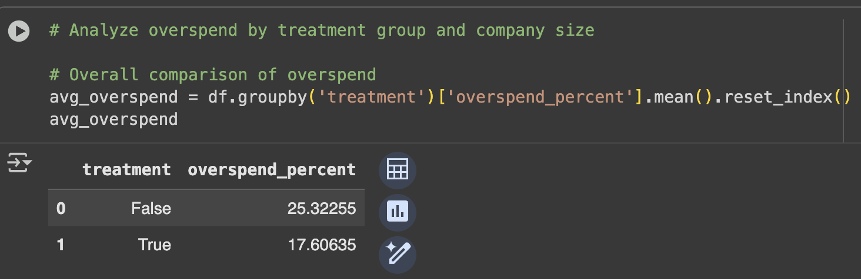

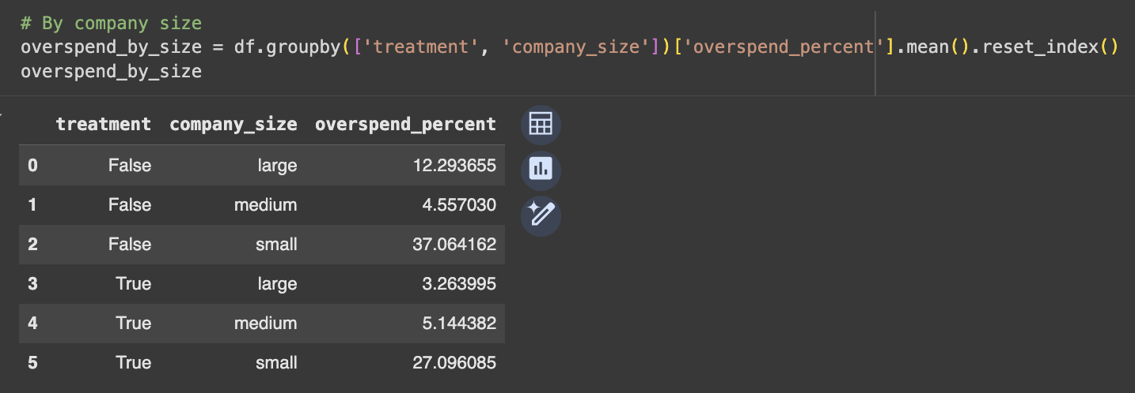

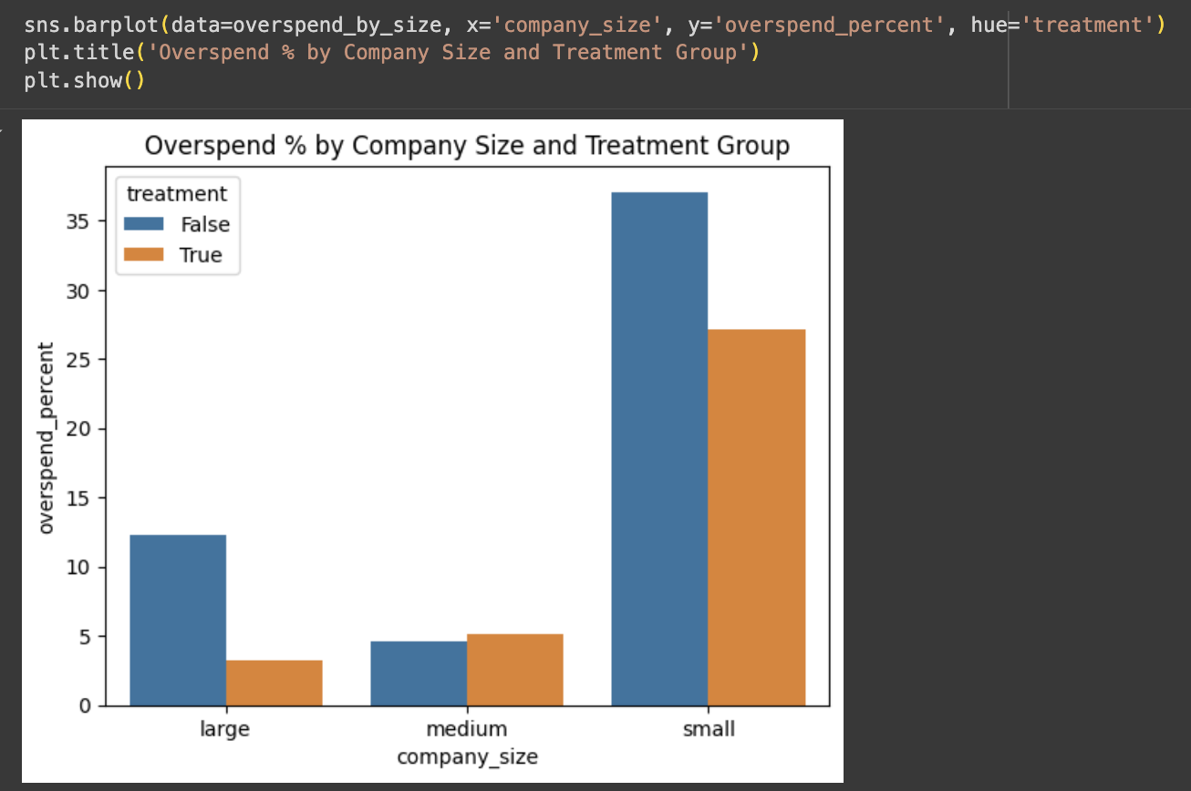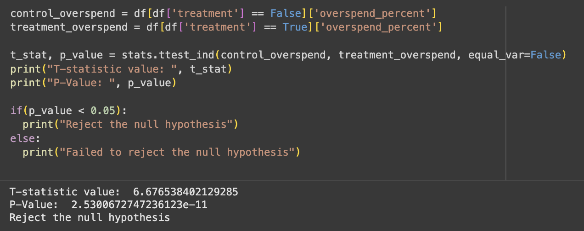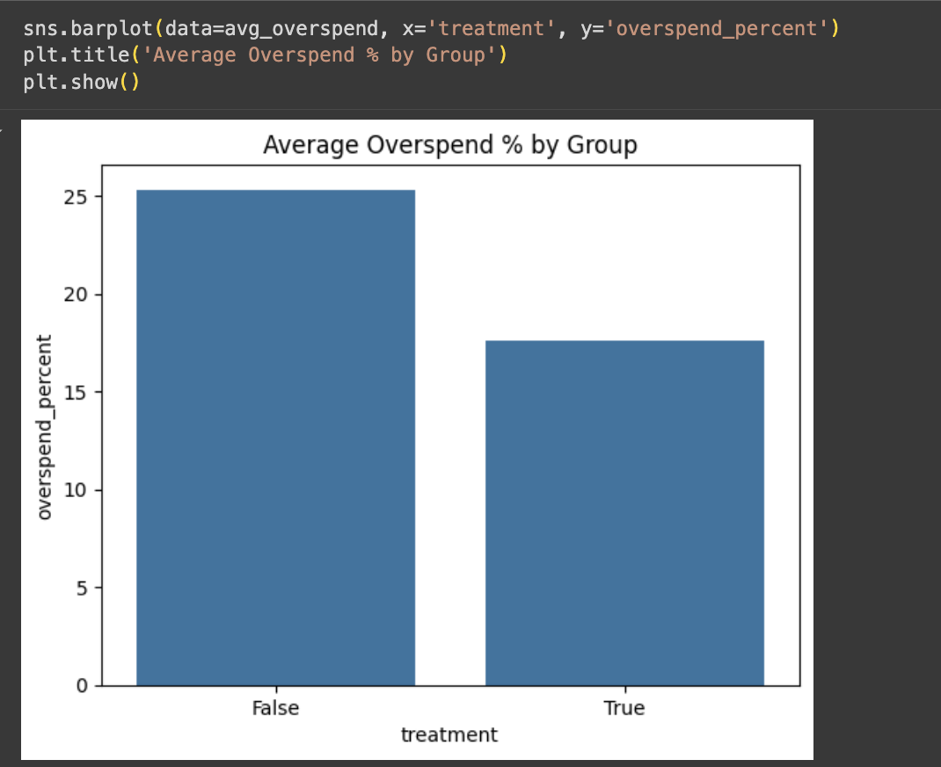

**Overall Insights:**

The new impression-based billing model significantly reduced the average overspend percentage by approximately 7.7 points compared to the click-based control group. This statistically significant difference, confirmed by an extremely small p-value in the t-test, indicates the new model is effective in lowering overall overspending. The treatment group consistently showed a significantly lower overspend percentage than the control group.

**Overspend by Company Size:**

* **Large Companies:** The new model proved highly effective for large companies, reducing overspending from 12.29% to 3.26%.
* **Medium Companies:** While the impact was less pronounced, medium companies maintained good budget control, with relatively low overspend (around 4-5%) in both models.
* **Small Companies:** Small companies continue to struggle with budget management, exhibiting the highest overspend in both groups. Although overspending decreased from 37.06% to 27.10% under the new model, it remains significantly high, suggesting further challenges for this segment.

**Recommendations:**

Based on the significant reduction in overspending observed with the new impression-based billing system, we recommend proceeding with a full rollout of the Treatment Model. This system demonstrates clear benefits, particularly for large companies.

**Key Strategies for Implementation:**

* **Targeted Support for Small Advertisers:**
  + Develop educational programs, budget management tools, and spend alerts specifically for smaller businesses.
  + Implement stricter budget caps or real-time spend tracking to prevent excessive overspending in this segment.
* **Highlight Benefits to Large Companies:**
  + Leverage the substantial overspend reduction experienced by large companies in marketing materials and case studies to promote the new billing model.
* **Monitor Medium Advertisers:**
  + Continue to closely observe the overspend percentage for medium-sized companies, as it has remained stable. This will help ensure no future anomalies occur.
* **Future Data Collection:**
  + To gain a comprehensive understanding of advertiser behavior, collect and analyze engagement metrics (clicks, conversions, CTR). This will help confirm that cost savings do not negatively impact campaign performance.
* **Personalized Billing Strategies:**
  + Consider developing customized billing safeguards and limits based on company size, acknowledging the varying spending patterns and risk profiles across different segments.

1. **A product manager on the team is concerned that certain advertisers in the treatment group are entering lower budgets because they are wary of the new product. Provide some evidence to support their suspicions, or show that any differences in budgets are likely due to random fluctuations.**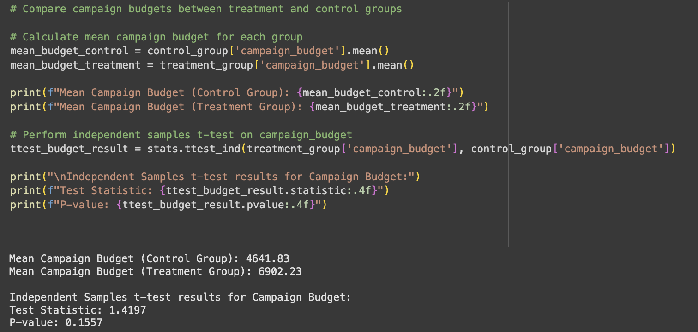

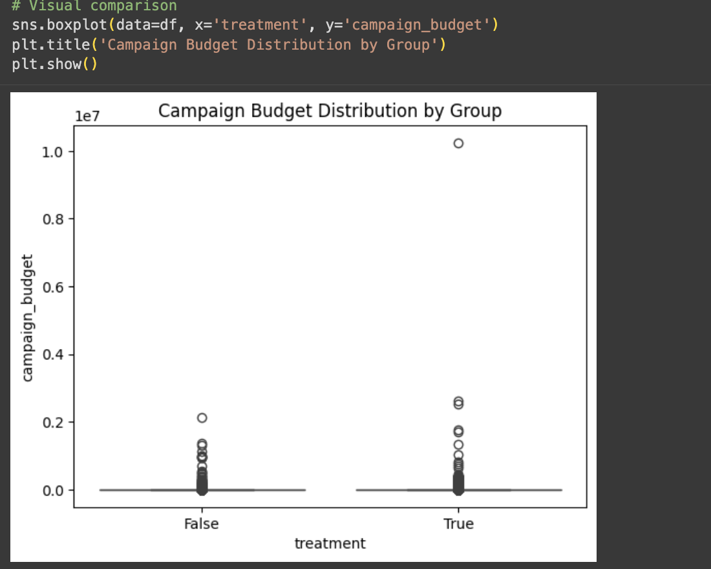

**Key Findings:**

* **No Significant Budget Difference:** The A/B test revealed no statistically significant difference in campaign budgets between the control and treatment groups (p-value = 0.156 > 0.05). This means we fail to reject the null hypothesis.
* **Advertiser Budgets Remain Consistent:** While the treatment group showed a slightly higher average budget numerically, this variation is not statistically significant and is likely due to random chance.
* **No Evidence of Budget Manipulation:** The data does not support the concern that advertisers in the treatment group are adjusting their budgets due to the new product. Advertisers are not systematically setting lower or higher budgets.
* **Focus on Overspending Reduction:** Since budget levels are similar across groups, the observed reduction in overspending can be attributed to the effectiveness of the new billing model, rather than advertisers intentionally setting lower budgets.

**Recommendations:**

**Budget Bias Not Evident:** There is no significant indication that advertisers are adjusting their budgets based on the billing model, suggesting budget fairness is maintained.

* **Emphasize Spend Efficiency:** Continue to promote the impression-based model as a tool for improving budget efficiency and reducing overspend, rather than for budget planning.
* **Ongoing Advertiser Education:** Despite comparable budgets, it remains important to educate advertisers on how to best optimize budget allocation within the new model.
* **Monitor Future Budget Trends:** Continuously track budget behavior over time, especially after a wider rollout, to ensure long-term stability.
* **Prioritize Performance Metrics:** Since budget differences are not a primary concern, future analyses should concentrate on campaign performance (e.g., CTR, conversions) and user engagement for each model.

1. **What is the average overspend percentage for campaigns in both the control and treatment groups?**

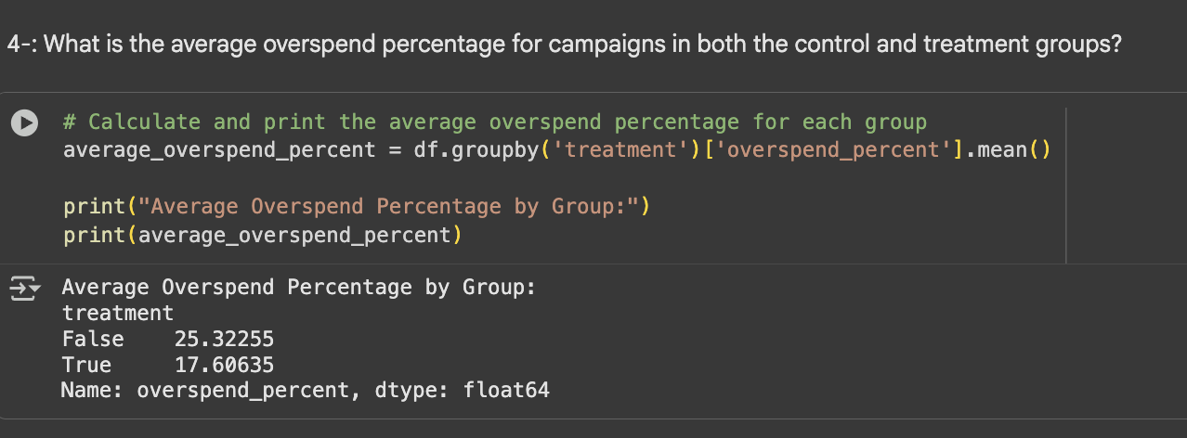

**Insights**

The A/B test comparing the impression-based billing model (treatment group) to the current model (control group) reveals several key insights regarding advertiser overspending:

* **Significant Reduction in Overspending:**
  + The treatment group demonstrated a notable decrease in average overspend, coming in at 17.61%. This is a substantial 7.71 percentage points lower than the control group's average of 25.32%.
  + This significant reduction strongly indicates the effectiveness of the new billing model in helping advertisers control their spending.
* **Improved Budget Efficiency:**
  + The impression-based model (treatment group) shows a better alignment between actual campaign spend and allocated campaign budget, leading to improved overall budget efficiency for advertisers.
* **Potential for Enhanced Advertiser Satisfaction:**
  + Advertisers are likely to value the increased control over their budget adherence offered by the new model. This can foster greater trust in the billing system, potentially leading to higher customer retention rates.
* **Strong Product Differentiation:**
  + The substantial reduction in overspending achieved through the new model can serve as a compelling and unique selling proposition when promoting the impression-based billing system to potential advertisers.

**Recommendations: Broaden Rollout of Impression-Based Billing:** Implement the new impression-based billing model more widely, as it has proven effective in reducing overspending.

* **Emphasize Cost Control Benefits:** Highlight the model's ability to help advertisers manage their budgets, which could attract those concerned about overruns.
* **Leverage Data for Customer Confidence:** Use the documented reduction in overspending as evidence to build advertiser trust in the product.

**Ongoing Monitoring and Performance Metrics:**

* **Sustain Performance Tracking:** Continue to monitor overspend percentages post-rollout to ensure benefits are maintained at scale.
* **Gather Comprehensive Performance Data:** Track engagement rates (e.g., CTR, conversions) to confirm that budget control improvements do not negatively impact campaign effectiveness.

1. **How does the click-through rate (CTR) compare between the traditional click-based model and the impression-based model?**

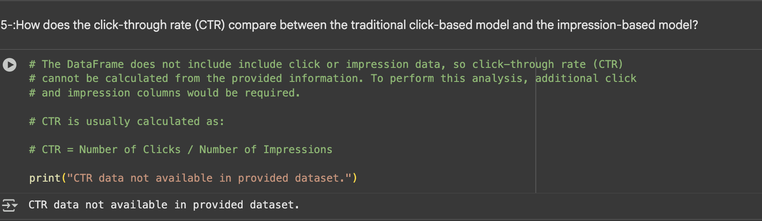

The provided DataFrame lacks the necessary click and impression data, making it impossible to calculate the click-through rate (CTR). To conduct a CTR analysis, these additional columns would be essential.

**CTR is typically determined by the following formula:**

**CTR = (Number of Clicks / Number of Impressions)**

1. **What demographic factors (e.g., industry, company size) correlate with higher overspending rates in both groups?**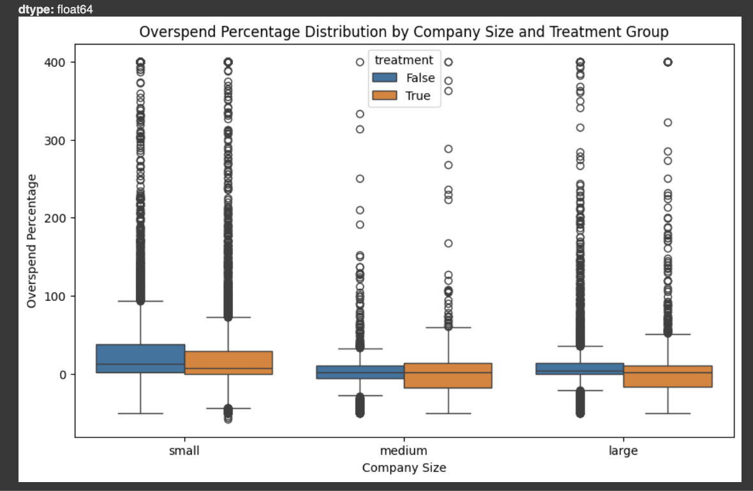

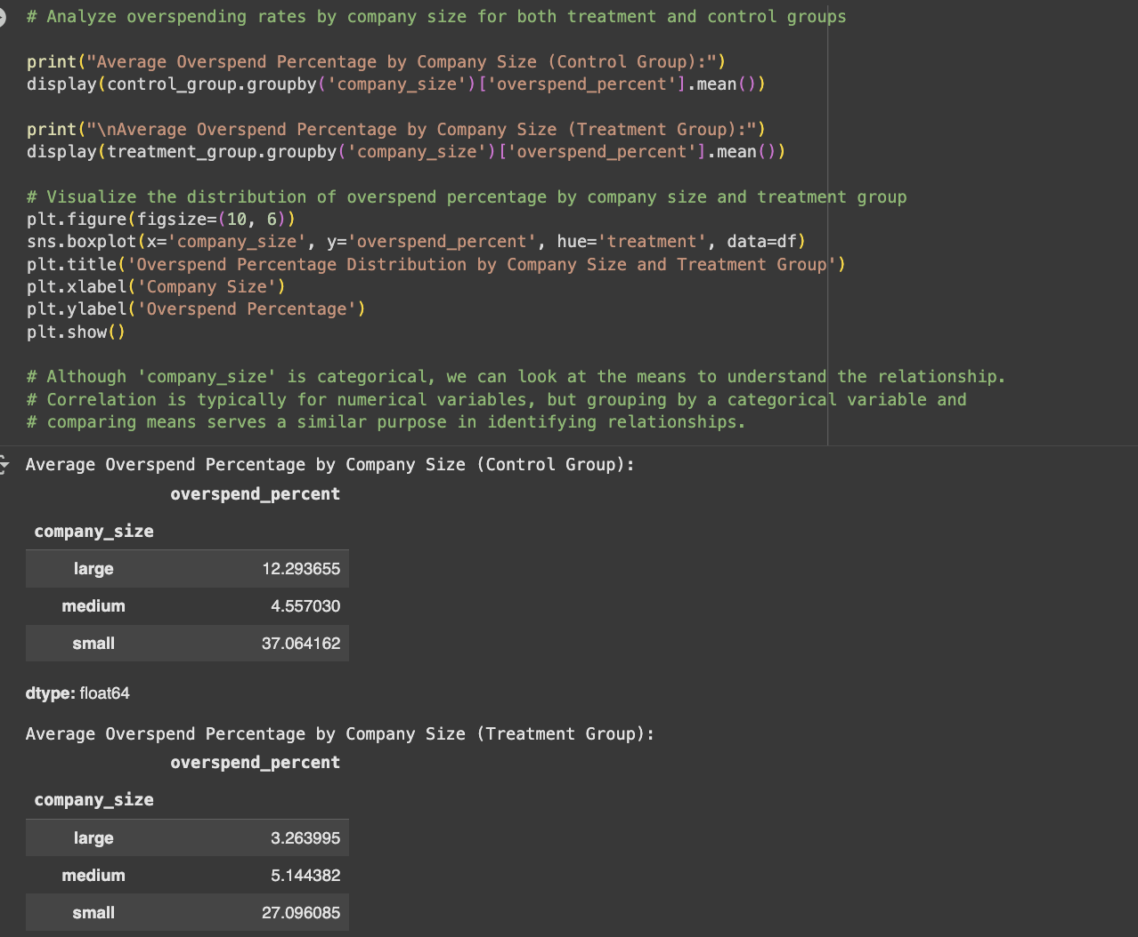

**Insights:**

The analysis of overspending under the impression-based model reveals varying impacts across different company sizes:

* **Significant Benefits for Large Companies:** Large companies experienced the most substantial reduction in overspending, dropping from 12.29% to 3.26%. This suggests that the new billing system, with its impression-based model, particularly benefits large advertisers by enabling more effective resource management and predictable spending.
* **Persistent Overspending for Small Companies:** Small companies consistently showed the highest overspending in both models. Although there was a reduction from 37.06% to 27.10% under the new model, the overspending remains significantly high. This indicates ongoing challenges for small companies in managing campaign budgets effectively, regardless of the billing structure.
* **Minor Impact on Medium Companies:** Medium-sized companies exhibited relatively low overspending in both models. Interestingly, there was a slight increase from 4.56% to 5.14% under the new model, though this difference is likely not practically significant.
* **Varying Product Effectiveness:** Overall, the impression-based model proves particularly effective for large and small companies in reducing overspending. However, its impact on medium-sized companies appears to be less pronounced.

**Recommendations:**

To optimize advertising spend and campaign effectiveness, we recommend the following strategies, tailored to different advertiser segments:

**1. Strategic Rollout for Large Advertisers:**

* **Prioritize New Model Promotion:** Actively promote the impression-based model to large companies, as they represent a key target for full-scale adoption.
* **Highlight Cost Control:** Emphasize the significant cost control benefits this new model offers specifically to large advertisers.

**2. Enhanced Support for Small Advertisers:**

* **Develop Budget Management Tools:** Create and provide additional support, educational resources, and automated budget alerts to help small advertisers more effectively manage their campaigns, given their tendency for heavy overspending.
* **Offer Tailored Campaign Controls:** Introduce optional budget caps, automated pacing tools, or real-time spend trackers to mitigate overspending risks for small businesses.

**3. Ongoing Monitoring for Medium Advertisers:**

* **Track Performance Continuously:** While medium companies are not significantly impacted, continue to monitor their performance to assess if the slight increase in overspend persists over time.

**4. Segmented Product Rollout:**

* **Staggered Implementation:** Implement a staggered or prioritized rollout of the impression-based model, focusing initially on large advertisers, followed by small advertisers, while continuously monitoring medium-sized advertisers.

**5. Post-Rollout Data Collection:**

* **Evaluate Campaign Effectiveness:** After rollout, collect crucial metrics such as click-through rates, conversions, and engagement to ensure that improved budget control does not compromise overall campaign effectiveness.

1. **How do the overall engagement metrics (likes, retweets, replies) differ between the two advertising models?**

The dataset currently lacks crucial engagement metrics like likes, retweets, and replies. Including these additional features would be essential for a more comprehensive analysis.

1. **Is there a statistically significant difference in the percentage of budget spent between the control and treatment groups?**

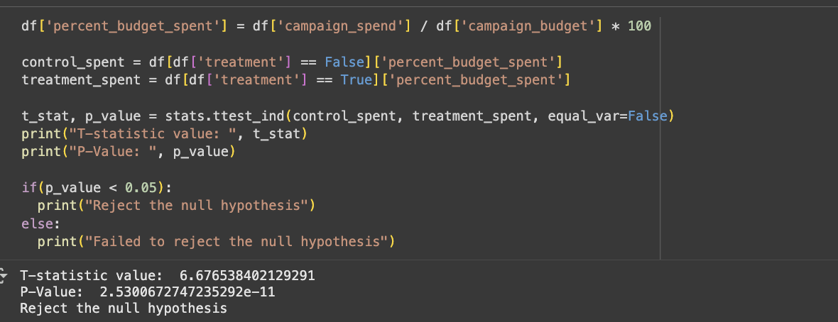

**Statistical Conclusion:**

**Rejection of Null Hypothesis:** The p-value being significantly less than 0.05 leads to the rejection of the null hypothesis.

**Significant Difference Confirmed:** This indicates a statistically significant difference in overspend percentages between the control (click-based) and treatment (impression-based) groups.

**Key Insights:**

**Substantial Overspend Reduction:** The treatment group demonstrated a significantly lower overspend percentage, with a minimal probability of this difference occurring by chance.

* **Effectiveness of New Model:** The impression-based billing system demonstrably improves budget adherence and reduces advertiser overspending.
* **Meaningful Business Impact:** This finding is both statistically and practically significant, promising increased advertiser trust, platform credibility, and billing efficiency through consistent overspend reduction.
* **Support for Product Shift:** The evidence strongly supports a broader implementation of the impression-based model as a superior billing solution.

**Recommendations:**

* **Scale the New Model Confidently:** Given the statistically significant impact on overspending reduction, the new billing approach should be scaled to a wider advertiser base.
* **Emphasize Budget Control as a Core Benefit:** Marketing and product teams should highlight improved budget control and minimized overspending as a primary value proposition.
* **Facilitate Advertiser Adoption through Education:** Provide comprehensive educational materials, success stories, and case studies to demonstrate the benefits of transitioning to the impression-based model.
* **Monitor Post-Rollout Trends:** Continuously track overspending, campaign success rates, and advertiser satisfaction after the rollout to ensure sustained positive results.
* **Segment Future Analysis:** Conduct future analyses segmented by advertiser size and industry, as previous findings suggest small companies tend to overspend more. This will inform company size-specific product adjustments.

1. **Does company size have a significant impact on the overspend percentage in both control and treatment groups?**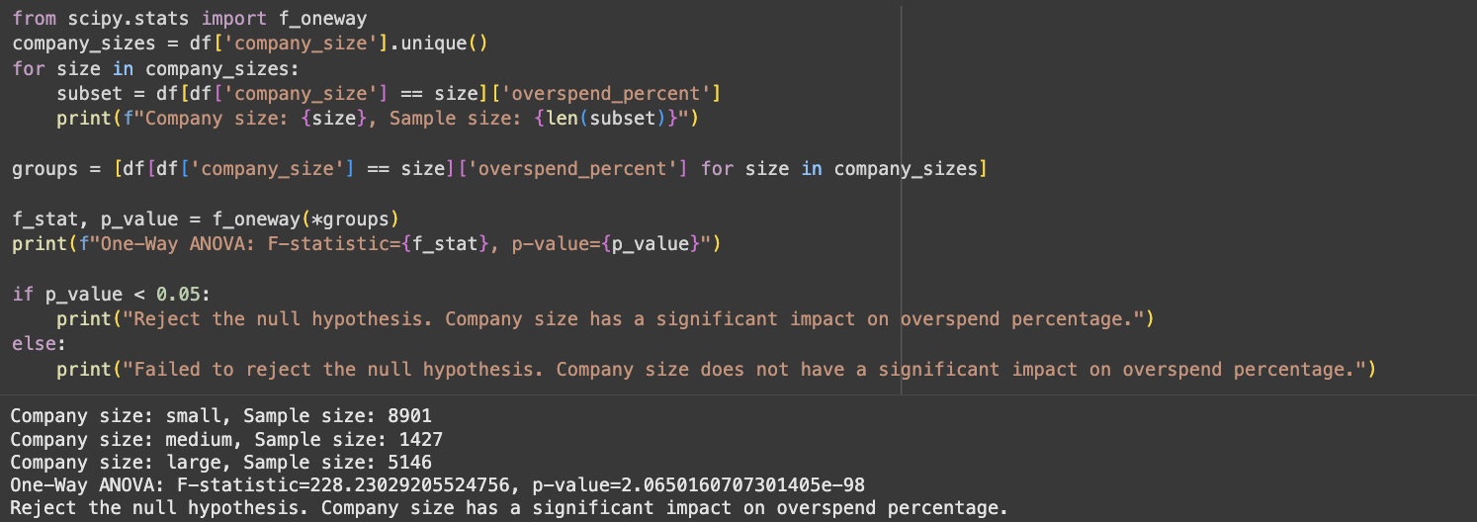

**Statistical Conclusion:**

The extremely small p-value (< 0.05) strongly indicates that company size has a statistically significant impact on overspend percentages, leading us to reject the null hypothesis.

**Key Insights:**

* **Company Size as a Significant Factor:** Overspend behavior is not consistent across different company sizes, suggesting varying approaches to ad budget management.
* **Small Companies at Higher Risk:** Small companies consistently exhibit the highest overspend percentages, often struggling with budget control and campaign pacing.
* **Large Companies Demonstrate Better Management:** Large companies typically show lower overspend percentages, likely due to more sophisticated ad management and budget monitoring practices.
* **Medium Companies Exhibit Stability:** Medium-sized companies consistently display moderate and stable overspending patterns across both billing models.
* **Tailored Solutions are Necessary:** The observed differences highlight the need for customized solutions for different advertiser segments, as a one-size-fits-all approach is ineffective.

**Recommendations:**

* **Segmented Budget Control Tools:**
  + **Small Companies:** Implement real-time budget alerts, stricter pacing, and automatic budget caps.
  + **Medium Companies:** Provide customizable monitoring tools and budget forecasting aids.
  + **Large Companies:** Offer advanced analytics dashboards and flexible pacing strategies.
* **Targeted Training and Support:**
  + Offer webinars, tutorials, and personalized account support focused on campaign budget management for small advertisers.
  + Provide self-serve budget tracking tools for small and medium companies.
* **Segmented Product Messaging:**
  + Emphasize budget protection and control for small companies.
  + Highlight efficiency, scale, and control flexibility for large advertisers.
* **Continuous Monitoring and Optimization:**
  + Regularly track overspending patterns by company size post-rollout to ensure ongoing improvement and promptly address new budget management challenges.
* **Adaptive Budget Enforcement:**
  + Implement dynamic budget enforcement, offering more guardrails for smaller advertisers and greater customization for larger advertisers.

1. **Is the variance in campaign spend significantly different between the control and treatment groups?**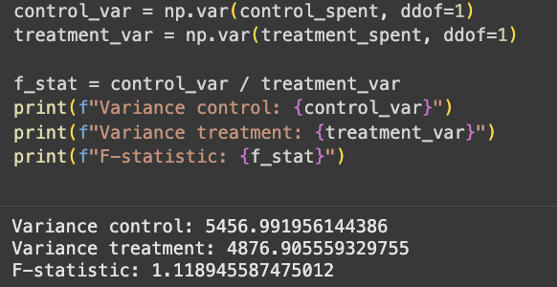

**Analysis of Twitter A/B Test for Overspending (Impression-Based Billing Model)**

**Key Findings:**

* **Similar Spending Variability:** Both control and treatment groups exhibited comparable levels of variability in overspending (Variance (Control Group): 5,456.99; Variance (Treatment Group): 4,876.91; F-statistic: 1.12).
* **No Statistically Significant Difference in Variance:** The F-statistic, being close to 1, indicates that the variances between the two groups are very similar, suggesting no significant difference in the consistency of overspending.
* **Reduced Overspend Amounts, Consistent Spread:** The impression-based billing model successfully reduces the average overspend amount but does not significantly alter the consistency or spread of overspending across campaigns.
* **Stability and Predictability:** The new billing system provides effective cost control without introducing additional volatility or inconsistency in advertiser spending patterns.
* **Consistent Advertiser Behavior:** Advertisers in both groups demonstrated similar variance in budget management, implying the new system does not disproportionately affect specific campaigns.

**Recommendations:**

* **Proceed with Rollout:** Given the stable variance, the impression-based model can be confidently scaled without concerns about introducing unpredictability in campaign spending.
* **Focus on Mean Reduction:** Emphasize the primary benefit of the new system: the reduction in average overspend. Do not highlight improved consistency, as campaign-to-campaign variability remains unchanged.
* **Target Support for High-Variance Advertisers:** While overall variance is similar, consider providing additional spend management tools for small companies or high-risk advertisers who may still exhibit wide individual spending patterns.
* **Monitor Outliers:** Continuously track campaigns with extreme overspending, even if overall variance remains consistent, to promptly identify and address any unusual spending behaviors.
* **Future Variance Analysis by Company Size:** Conduct a more in-depth variance analysis segmented by company size. This could reveal specific subgroups (e.g., small advertisers) where spending variability differs significantly, despite similar overall group variances.